ASSIGNMENTS ON DIGITAL MARKETING

NAME : BOOPATHI D
DEPARTMENT : B.E.BIOMEDICAL ENGINEERING
COLLEGE: 8151 DHANALAKSHMI SRINIVASAN INSTITUTE OF
TECHNOLOGY
NAANMUDHALVAN COURSE : DIGITAL MARKETING
NM TEAM ID : NM2023TMID02352
NM ID : 18F724D6D3FE014A8FA4E7220A89EBAC

ASSIGNMENT 1:
Create a blog or website using Blogspot and WordPress. Customize
The theme design and post new article with 500 words.
Website: https://phoenixmenswear4.wordpress.com/2023/10/19/elevate-your-style-phoenix-menswear-your-gateway-to-premium-mens-fashion/
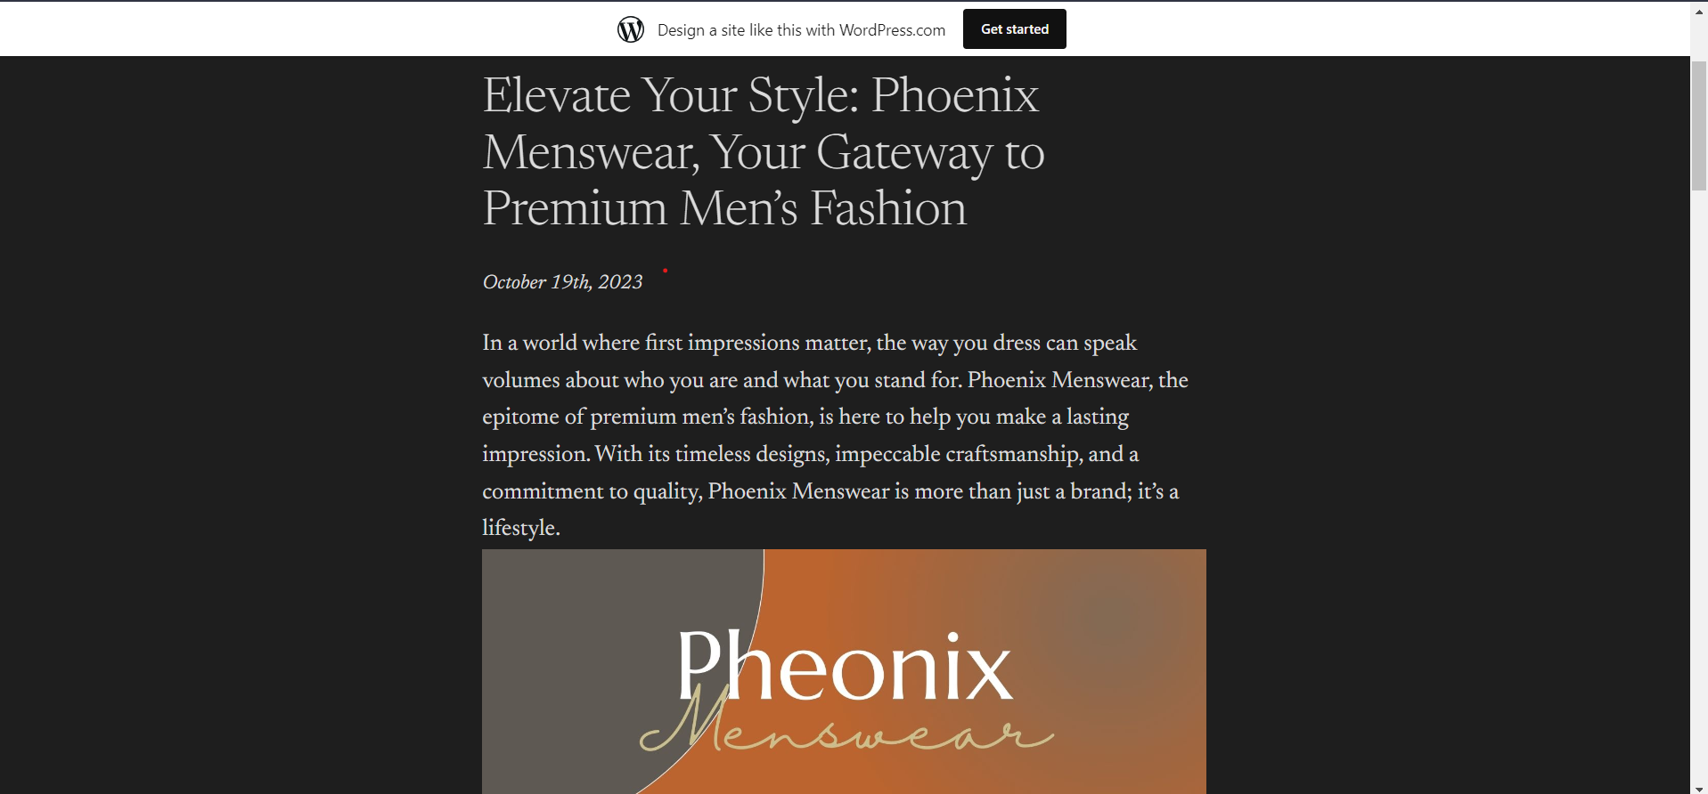

ASSIGNMENT 2:
Create a new Facebook business Page and Post one social media poster for your brand.
Website: https://www.facebook.com/profile.php?id=61550800671112&mibextid=b06tZ0

ASSIGNMENT 3:
Create and design a social media advertisement poster using Canva


.
ASSIGNMENT 4:
4.Create email newsletter design using MailChimp or Canva tool.


